On the Mark Investing Club

Stock Presentation

December 8, 2014

Company Summary
ON Semiconductor is a vendor of analog power management, analog signal conditioning, standard logic ICs and discrete chips into the automotive, communications, computing, consumer, industrial, and medical applications. The company is in the midst of a transformation from a seller of commodity discrete chips into higher value added analog ICs both through organic growth and acquisitions

Selection Background
ONNN is one of the three stocks that was added to the 4x/KBA stock screen. Since it is also recommended by lessor experts.

Reasons for the Recommendation

From a Technical perspective a BUY short, medium and long term.
- Current Price is $10.22 compared to an Intrinsic value $25.76
- Analyst Ratings:
  - BofA/Merrill Lynch – BUY
  - S&P Capital IQ – BUY
  - Schwab – BUY (Outperform)
  - Credit Suisse – Outperform
  - Ned David Research – BUY

What I Like
- Market and representative end users
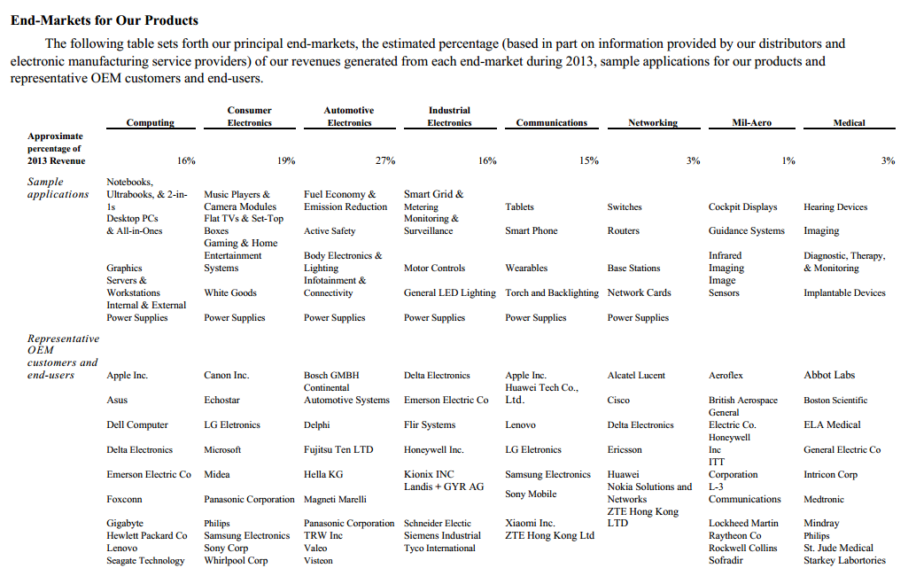)
- Acquisitions of market leader imaging companies (Aptina Imaging)
- Earning forecast/outlook
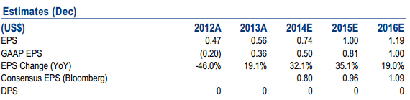

What I do NOT Like
- Revenue over the past years has been up and down
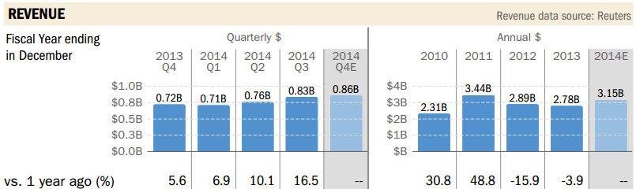
- Risk assessment
